AGRCULTURE ANNUAL REPORT FOR 2015

INTRODUCTION
The agriculture project at ARO Development Centre was initiated in January 2015.
The main aim of the project was to promote food security and economic empowerment. The children sponsored by ARO Centre and their caretakers are the primary target groups. The secondary target groups are farmers in the surrounding community and other stake holders.

In 2015, 130 children under ARO Childcare program and their caretakers benefited directly from the project through trainings and participation in growing crops for the centre and their own crops for consumption at home.

CARETAKER FARMERS

A total of 30 caretaker farmers were recruited to participate directly in the project, 15 of them during the first rainy season and another 15 during the second season in 2015.

In each season every caretaker farmer participating in the project was assisted through ploughing of 0.5 acre of their farms together with provision of maize and beans seeds for planting on their portions of farms. (0.5 acres)

The first farming season ran from February to August 2015 whereas activities for the second season started in September 2015 through to January 2016.

It is worth noting that the caretaker farmers were divided in small groups of five people according to their closeness in the areas of residence. This was meant to encourage consultations among themselves on operations on their farms and also to facilitate giving them practical empowerments at home level, together with monitoring their progress in agri- business.

The farms of caretaker were used as model farms in the various communities where they are located.

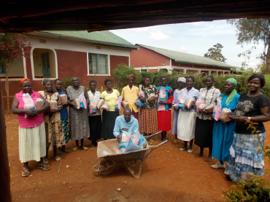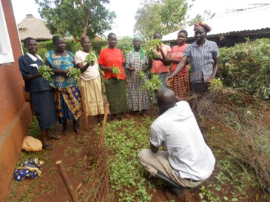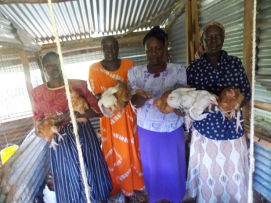
Seedlings distributed to caretakers. Learning on horticulture management. Caretakers learning poultry keeping.
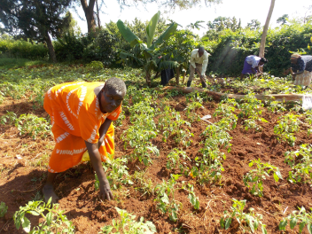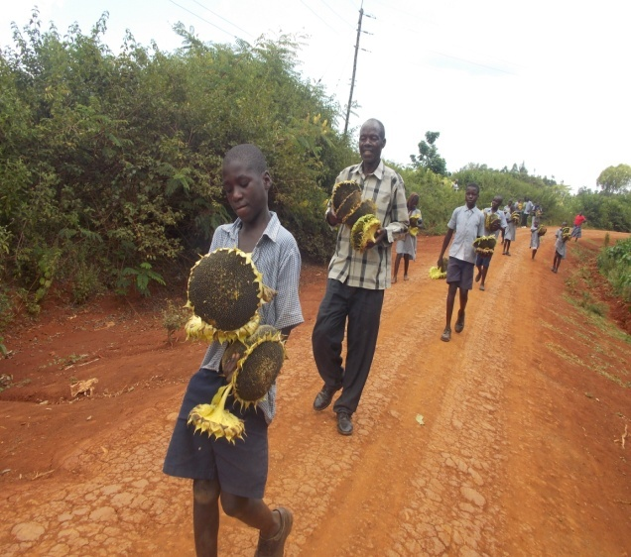
Caretakers in their tomatoes’ farms. Children participated in harvesting Sunflower

DEMONSTRATION PLOTS
Apart from monitoring activities of the farms of caretakers,
ARO Development Center had its own demonstration plots which were used to grow food for the childcare department.
The plots acted as model farms where the local community learnt appropriate farming practices for high crop yields which promote food security and improved incomes.
Demonstration plots within the center were used mainly for growing vegetables and fruits. It is encouraging to note that during the whole of 2015 there was continuous harvesting of vegetables like kales, black night shade, Tomatoes, Spider weed and cow peas among others for use by the childcare department for feeding program.
The plots outside center were planted with field crops such as maize, sorghum, beans, ground nuts, simsim and green grams etc.

Growing of sunflower was also introduced during the second farming season with a view to using its produce in making poultry feed at the center. This will be done after pressing oil from the seeds, harvesting of the sunflower would be done in January/February 2016 from the two acres that were planted with the crop. Another 4 acres were planted elsewhere through caretaker farmers – report of which will be produced by March.

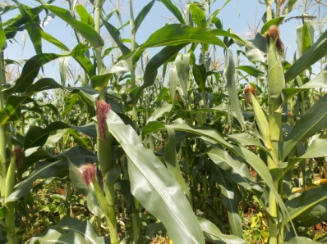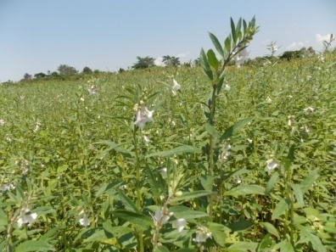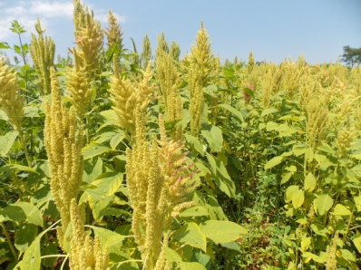
Maize farm Simsim farm. Amaranth farm.

TRAININGS
In order to empower the caretaker farmers to undertake farming as a business, a total of 4 trainings were organized at ARO Center. The trainings were conducted at different times of the year coinciding with the urgency of particular information.
The major topics which were covered in these trainings were:
- Techniques in farm operations for various crops
- Preparation and use of compost manure
- Striga weeds and methods of controlling it.
- Record keeping.
- Farming as a business.
- Sun flower growing and usage.

These trainings were conducted in collaboration with by extension officers from the ministry of Agriculture, Livestock and Fisheries in Bondo Sub County. The personnel under the project also covered more training with the caretaker farmers in the fields as was necessary.

PARTICIPATION WITH CHILDREN
The 130 children under the ARO childcare program were involved in the various farm operations throughout the year as a way of providing them with skills for life. Their involvement was mostly limited to their capacities according to their ages.
During the various farm operations the personnel leading them in such activities took time to explain to them the importance of doing such work correctly in relation to the yields that would be expected.

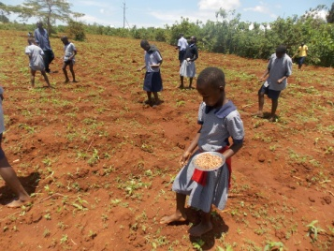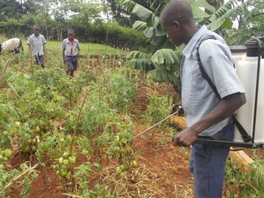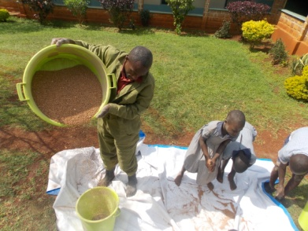
ARO children planting beans. A child spraying vegetables. Children learning crop preparation and storage.

CROPS AND YIELDS
Harvesting of vegetable crops planted on the demonstration plots within ARO Center took place in bits throughout the year.
For beans grown during the first season and harvested in June 2015, reports from the caretaker famers indicated different levels of yields from their 0.5acre plots ploughed. The highest was 50kg whereas the lowest reported 12kg, it was later discovered that the caretaker farmers feared telling the truth and assumed wrong impression that they would be asked to surrender part of their harvest. Efforts have been made to ensure them that they are being empowered to grow their own food.

Reports from ARO plots outside the center are listed below:-

CROP | KILOGRAMS
Beans | 70kg
Maize | 350kg
Sorghum | 280kg
Amaranth | 40kg
Green grams | 14kg
Simsim | 12kg
Groundnuts | 220kg
Caretaker farmers reported yields of maize varying between 80kgs and 400kgs from their 0.5 acre plots.
Crops grown in the second season of 2015 would be harvested in January 2016.

ACHIEVEMENT
- The agriculture project for the ARO childcare department has been very beneficial in initiating efforts towards food security and economic empowerment during 2015.
- It has enabled the childcare department to grow a lot of their own food, in addition to empowering caretakers improve their food security at home.
- It has also built the capacity of the ARO children in agricultural production to some basic level which would benefit them in future.
- Communities at large have benefitted through free trainings and this has lead to food security among majority of farmers within the locality.
- Change of attitude in adopting to new technology in agriculture
- Adoption of farming as a business hence improved livelihood.

CHALLENGES
- The need to undertake farm operations on time
- Insincerity by the caretakers, giving inaccurate report on farm produce while fearing about organization taking back from them.
- Slow learning process by farmers due to high levels of illiteracy
- High rate of HIV/AIDS Infection rendering most farmers vulnerable
- High rate of chicks death which are imported from different hatcheries.
- Unpredictable weather patterns due to climatic changes.

RECOMMENDATION
- Efforts should be made by agriculture team in coordination with the tractor department and the caretakers to address them as the project continues.
- Project to be continued for more years to enable achievement of goals.
- Encourage use of modern technology ie. Value addition
- Acquisition of oil press machine, maize Sheller machine,
- Acquisition of egg Hatcher/incubator would address problems of high death rate of chicks.

CONCLUSION
In overall, the project has started to benefit the community through trainings, direct participation of the children and their caretakers by extension, the local community through learning from the demonstration plots. Its continuation is expected to create a lot of impact for the immediate future.

APPRECIATION
Much appreciation goes to the donors, supporters and the government technical team who worked together with us during the year 2015 in realization of the achievements mentioned above.
We also want to appreciate our local partners, the caretaker farmers, Aro children who actively participated in the program. It was a learning process for them.
To our employees, we managed to achieve our 2015 goals through your dedicated efforts. Your efforts were marvelous.

